The Islamia University of Bahawalpur
Department of Information Technology



SOFTWARE DESIGN DESCRIPTION
(SDD DOCUMENT)
for

DeepDrive: A Deep Learning Approach to Car Model Recognition

Version 1.0

By
Muqit ur Rehman
Roll No F22BINFT1M01001
&
Saad Hassan
F22BINFT1M01026
Session Fall 2022 – 2026

Supervisor
Prof. Dost Muhammad khan

Bachelor of Science in Information Technology

Table of Contents
Introduction 1
Design methodology and software process model 1
System overview 1
Design models [along with descriptions] 1
Data design 2
Algorithm & Implementation 2
Software requirements traceability matrix 2
Human interface design 3
Appendix I 3

Revision History

Name | Date | Reason for changes | Version

Application Evaluation History

Comments (by committee)  *include the ones given at scope time both in doc and presentation | Action Taken

Supervised by
Prof. Dost Muhammad Khan

Signature

1. Introduction
The car classifier project has progressed through several stages, encompassing the following key modules:

1.1 Model Training Module
Scope: This module involves the development and training of the car classification model. It covers the ingestion of labeled datasets, model training using machine learning frameworks like TensorFlow or PyTorch, and validation of the model's accuracy.

1.2 Model Deployment Module
Scope: The Model Deployment Module focuses on the serialization of the trained model for deployment. It includes the development of RESTful APIs using the Django framework to expose the classification model, ensuring seamless integration with other system components.

1.3 API Consumption Module (Next.js)
Scope: This module deals with the integration of the Next.js frontend with the Django backend. It allows users to consume the exposed APIs, submit images for classification, and view the results through a user-friendly web interface.

1.4 User Authentication Module
Scope: The User Authentication Module covers the implementation of user registration and login functionalities. Users can register accounts, log in securely, and access personalized features based on their roles.

1.5 System Administration Module
Scope: This module focuses on system administration features, including model monitoring for administrators to track the performance of deployed models and user management to oversee accounts and roles.

2. Design Methodology and Software Process Model

2.1 Design Methodology

The car classifier project adopts an Object-Oriented Design (OOD) methodology. Object-oriented design focuses on organizing code into reusable and encapsulated objects, which represent real-world entities, and promotes concepts such as inheritance, encapsulation, and polymorphism.

2.1.1 Justification:

Modularity: OOD promotes modularity, allowing for the creation of reusable and maintainable code through the encapsulation of data and behavior within objects.

Abstraction: It facilitates abstraction by modeling real-world entities with objects, making the design more intuitive and closer to the problem domain.

Encapsulation: OOD supports encapsulation, which enhances security and reduces code complexity by hiding the internal details of objects.

Inheritance: Inheritance helps in creating a hierarchy of objects, allowing the reuse of code and the establishment of relationships between objects.

2.2 Software Process Model

The project follows the Iterative and Incremental Development Model. This model breaks down the software development process into smaller, manageable cycles, with each cycle involving planning, designing, implementing, and testing specific features or functionalities. The key reasons for choosing this model include:

Flexibility: It allows for flexibility in adapting to changing requirements or introducing new features at the beginning of each iteration.

Early Delivery of Features: Incremental development enables the early delivery of a subset of features, providing stakeholders with tangible progress and the opportunity for early feedback.

Continuous Improvement: Each iteration builds upon the previous one, incorporating lessons learned and improvements to the system.

3. System Overview

The car classifier system is designed to identify and categorize different types of cars from images. It consists of several key modules, including Model Training, Model Deployment, API Consumption (Next.js), User Authentication, System Administration, and Error Handling. These modules are interlinked to create a comprehensive and efficient system.

4. Architectural Design

4.1 Modular Program Structure

The system is structured in a modular fashion to ensure maintainability, reusability, and clarity. Each module is designed to handle a specific aspect of the car classifier system:

Model Training Module: Handles the training of the car classification model.

Model Deployment Module: Manages the serialization and deployment of the trained model as well as the development of APIs using Django.

API Consumption Module (Next.js): Integrates with the Django backend to allow users to submit images for classification.

User Authentication Module: Manages user registration, login, and role-based access control.

System Administration Module: Provides features for monitoring model performance and managing user accounts.

Error Handling Module: Ensures robustness by handling errors during data ingestion, model training, and API consumption.

5. Process Flow/Representation

5.1 Activity Diagram
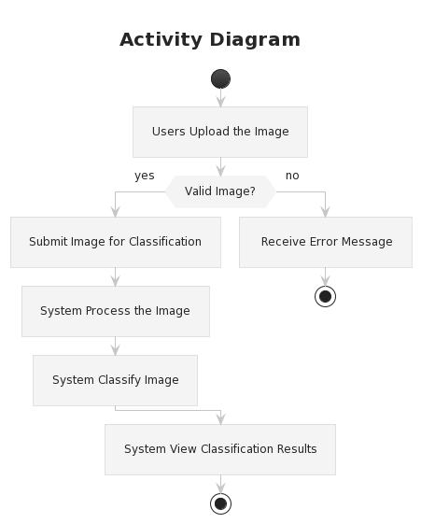

This activity diagram represents the major processes within the car classifier system. It provides a visual representation of the flow of activities, including user interactions, system responses, and the overall sequence of operations.

The iterative and incremental development process allows for the refinement of activities in each iteration, ensuring continuous improvement and adaptability to changing requirements.

This design methodology and architectural overview set the foundation for the detailed design and implementation phases, providing a clear roadmap for the development team.

6. Design models

6.1 Class Diagram

A class diagram represents the static structure of the system by showing classes, attributes, methods, and relationships. Here's a simplified class diagram for the car classifier system:

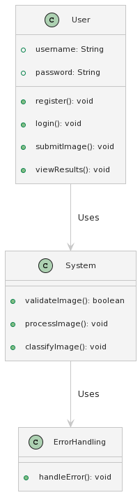

6.2 Sequence Diagram:

A sequence diagram illustrates how objects interact in a particular scenario of a use case. Here's a simplified sequence diagram for the user submitting an image:

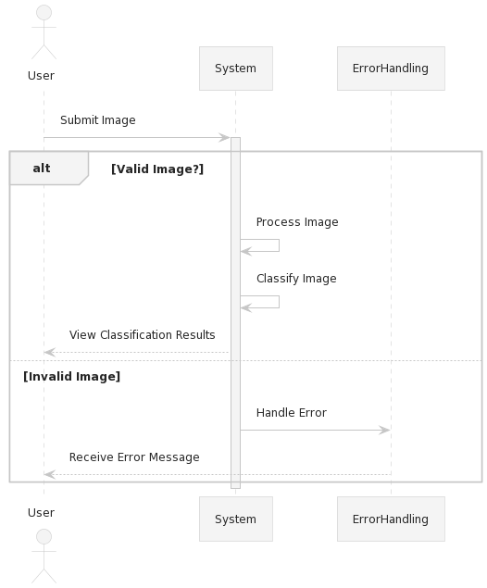

6.2 State Transition Diagram:

A State Transition Diagram models the different states an object can be in and how it transitions between those states. For simplicity, let's consider a state transition for the User authentication process:
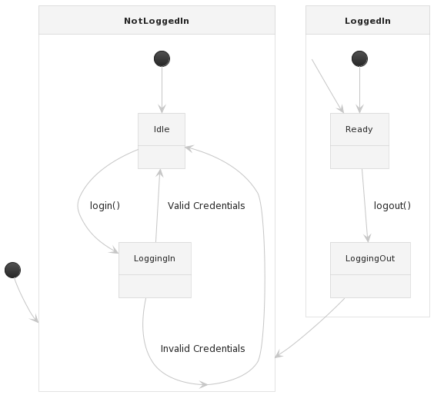

6.2 Dataflow diagram:

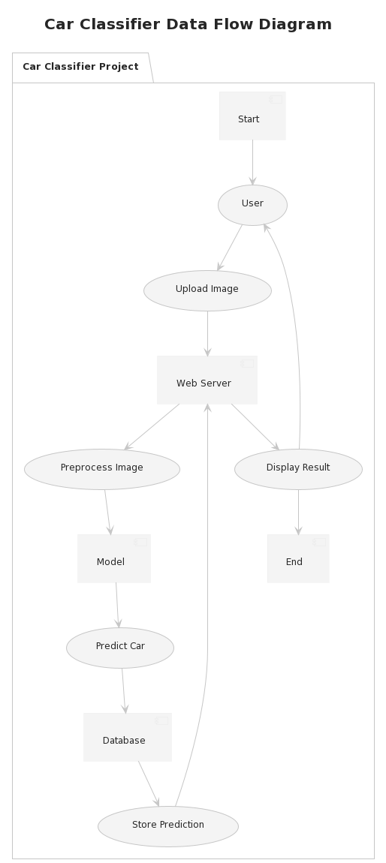

7. Data Design

The data design of the car classifier system involves transforming the information domain into data structures, specifying how major entities are stored, processed, and organized. Additionally, a data dictionary is provided, listing system entities, their types, and descriptions.

7.1 Data Storage

The major entities in the car classifier system are primarily stored in a relational database for efficient organization and retrieval. The data storage items include:

User Data:
Stores user information such as username, password (hashed for security), and user roles.

Image Data:
Stores information about uploaded images, including image ID, user ID (foreign key), file path, and timestamp.

Model Data:
Stores details about trained models, including model ID, user ID (foreign key), file path, timestamp, and
model metadata
.

Classification Results:
Stores the results of image classification, including image ID (foreign key), classification label, confidence score, and timestamp
.

7.2 Data Dictionary

1. User Data:

Attributes:
user_id (Primary Key)
username (String)
password (Hashed String)
role (String, e.g., "user" or "admin")

2. Image Data:

Attributes:
image_id (Primary Key)
user_id (Foreign Key to User Data)
file_path (String)
timestamp (DateTime)

3. Model Data:

Attributes:
model_id (Primary Key)
user_id (Foreign Key to User Data)
file_path (String)
timestamp (DateTime)
metadata (Text)

4. Classification Results:

Attributes:
result_id (Primary Key)
image_id (Foreign Key to Image Data)
label (String)
confidence_score (Float)
timestamp (DateTime)

7.3 Functions and Parameters

User Management Functions:
register(username: String, password: String): User
login(username: String, password: String): User
logout(user_id: Integer): void
getUserById(user_id: Integer): User

Image Processing Functions:
uploadImage(user_id: Integer, file_path: String): Image
processImage(image_id: Integer): void

Model Training Functions:
trainModel(user_id: Integer, file_path: String, metadata: Text): Model

Classification Functions:
classifyImage(image_id: Integer): ClassificationResult

7.4 Objects and Attributes (Object-Oriented Description)

User Object:
Attributes:

user_id: Integer
username: String
password: String
role: String

Image Object:
Attributes:

image_id: Integer
user_id: Integer
file_path: String
timestamp: DateTime

Model Object:
Attributes:

model_id: Integer
user_id: Integer
file_path: String
timestamp: DateTime
metadata: Text

Classification Result Object:
Attributes:

result_id: Integer
image_id: Integer
label: String
confidence_score: Float
timestamp: DateTime

This data design ensures a structured and organized approach to handling user data, image information, trained models, and classification results within the car classifier system. It facilitates efficient data storage, retrieval, and processing.

8. Algorithm & Implementation:

8.1 User Management Functions

8.1.1 register(username: String, password: String): User
Algorithm:
1. Validate username and password.
2. Hash the password.
3. Create a new User object with the provided username and hashed password.
4. Save the User object to the User Data table in the database.
5. Return the created User object.

8.1.2 login(username: String, password: String): User
Algorithm:
1. Validate username and password.
2. Retrieve the User object from the User Data table based on the provided username.
3. Compare the hashed password with the provided password.
4. If the passwords match, generate a session token and update the User object.
5. Return the User object with the session token.

8.1.3 logout(user_id: Integer): void
Algorithm:
1. Validate the user ID.
2. Retrieve the User object from the User Data table based on the provided user ID.
3. Clear the session token in the User object to log out the user.
4. Save the updated User object to the database.

8.1.4 getUserById(user_id: Integer): User
Algorithm:
1. Validate the user ID.
2. Retrieve the User object from the User Data table based on the provided user ID.
3. Return the User object.

8.2 Image Processing Functions

8.2.1 uploadImage(user_id: Integer, file_path: String): Image
Algorithm:
1. Validate user ID and file path.
2. Create a new Image object with the provided user ID and file path.
3. Save the Image object to the Image Data table in the database.
4. Return the created Image object.

8.2.2 processImage(image_id: Integer): void
Algorithm:
1. Validate the image ID.
2. Retrieve the Image object from the Image Data table based on the provided image ID.
3. Process the image (perform necessary operations).
4. Update the Image object with processing details.
5. Save the updated Image object to the database.

8.1.3 logout(user_id: Integer): void
Algorithm:
1. Validate the user ID.
2. Retrieve the User object from the User Data table based on the provided user ID.
3. Clear the session token in the User object to log out the user.
4. Save the updated User object to the database.

8.1.4 getUserById(user_id: Integer): User
Algorithm:
1. Validate the user ID.
2. Retrieve the User object from the User Data table based on the provided user ID.
3. Return the User object.

8.3 Model Training Functions

8.3.1 trainModel(user_id: Integer, file_path: String, metadata: Text): Model
Algorithm:
1. Validate user ID, file path, and metadata.
2. Create a new Model object with the provided user ID, file path, and metadata.
3. Save the Model object to the Model Data table in the database.
4. Return the created Model object.

8.4 Classification Functions

8.4.1 classifyImage(image_id: Integer): ClassificationResult
Algorithm:
1. Validate the image ID.
2. Retrieve the Image object from the Image Data table based on the provided image ID.
3. Retrieve the model to be used for classification (e.g., the latest trained model for the user).
4. Perform image classification using the selected model.
5. Create a new ClassificationResult object with the classification details.
6. Save the ClassificationResult object to the database.
7. Return the created ClassificationResult object.

9. Human interface design
Describe the functionality of the system from the user‟s perspective. Explain how the user will be able to use your system to complete all the expected features and the feedback information that will be displayed for the user.

Screen images

Display screenshots showing the interface from the user‟s perspective. These can be hand- drawn, or you can use an automated drawing tool. Just make them as accurate as possible. (Graph paper works well.)

The UI of this Application is still under consideration but here’s a rough sketech

